The East End of London:

The “East End” of London is located at the north of the River Thames and the east of the medieval walled City of London. Even though there are no clear formal borders to distinguish parts of the East End of London, it covers Barking and Dagenham, Havering, Newham, Redbridge, Tower Hamlets and Waltham Forest. The term “East End” was one which was used as a prerogative sense which began in the late 19th century. It was one of the poorest areas of London, associated with poverty, crime, prostitution, high rates of unemployment, overcrowding, a great deal immigrants settled in the area in the past which has included the Irish, Huguenots, the Jews and currently the Bangladeshi’s and Somali’s. Below is a map of London, showing all the London Boroughs. The East London Mosque and the London Muslim Centre is one of the most busiest and vibrant Islamic centres in Western Europe, it is located at the heart of Tower Hamlets

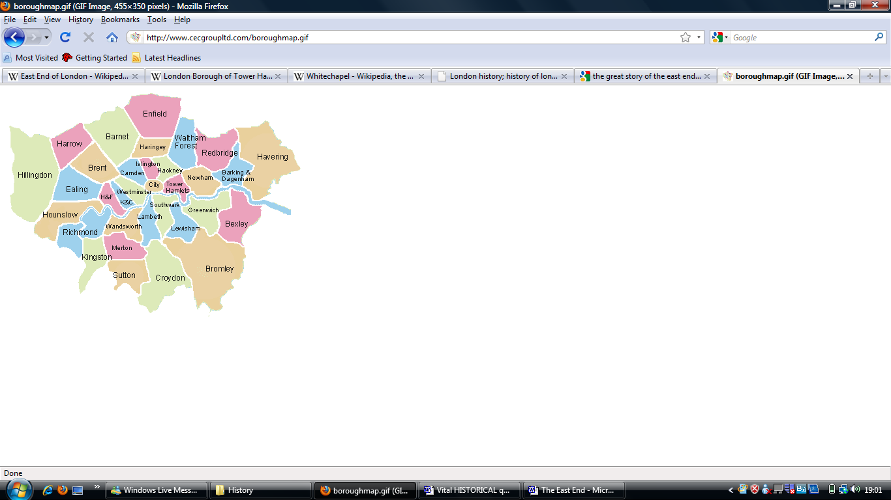
The East London Mosque and the London Muslim centre

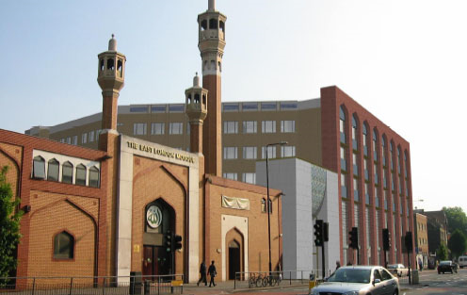

Timeline of the various East London settlers:

5th Century-16th Century |  | Middle Ages and the Tudor times:  People settled in the East London area, more specifically Whitechapel, Stepney Green and Bow, this was mainly for the purpose of shipping around the Thames. The riverside became a lot more active during the Tudor times. Royal navy and International trading developed during the middle ages.
14th Century |  | Flemish workers settled in the area
15th Century
16th Century |  | Dutch traders settled in East London
17th Century |  | French Huguenots settled in the East End of London around Bethnal Green, Whitechapel, Stepney Green, Mile End and Bow.  The East London was thriving with people; it was crowded and built with housing around Mile End to accommodate the flow of people and the movement of people around the area after the Great Fire of London in 1666.  Small community of Bangladeshis started arriving in London on the P&O mail and passenger ships as Bengali Lascars (sailors).
18th Century | 1800 | Irish workers entered the East End.  There was a sudden increase in population around Bethnal Green of Weavers to improve the silk weaving industry.
19th Century | 1801- 1831  1820’s  1824’s  1870’s  1870-1890  1900 | Eastern European Jews and the Bangladeshis settled in the East End of London  The Population around Bethnal Green trebled, adding to the overcrowding and poor housing conditions. The silk weaving industry attracted many more French weavers from France who entered the East End and settled in the area, the French were known as the Huguenots (who were well known for the membership with the protestant Reformed church of France). As the area became populated with more and more Huguenots the rich sold their land and moved on to the suburbs and other spacious areas allowing the Huguenots to take over the area of Globe town and most of the East End. Some Huguenots worked from home, houses were built to meet the requirements of the silk weaving industry, some still present, standing rock solid on Fournier street, with wide windows and three floored housing, the top of which was for the weavers.  Open fields were transformed into small estates for workers; tower blocks were built to accommodate for local people and deal with the overcrowding around the area.  The silk weaving industry was declining as the importation of French silks were restricted, as warehouses were already established around the East End of London, the use of cheap labour was transformed into boots, furniture and clothing industry, spaces were utilised in the best way possible  Britain had the world’s largest industrial power, with a large British Empire; it therefore attracted a wave of Germans, French, Jews, Asians as well as the Irish over the centuries. Even though housing was an issue around East London, employment was not, it attracted workers who gained support and had group communication  Many Eastern European Jews started settling around the East End of London. Over 150 synagogues were built in that period of time, even the Brick Lane Mosque, (previously a Chapel) was transformed into a Synagogue, in between the East London Mosque and the London Mosque Centre remains the Fieldgate street Synagogue, which was closed recently in 2008. Today there are ONLY 3 active synagogues in Tower Hamlets, these are:  - Sandys Row Synagogue (opened in 1766) by Refugee French Huguenot as a community church in Bishops gate on Artillery Street.  - The Congregation of Jacob Synagogue (opened in 1903).  - The East London Central Synagogue  There was an increase in the Jewish population around the East End during the 1890s; restrictions were put in by MPs on the flow of Immigrants in the 1900s. It was the Aliens Act 1905 that reduced and restricted the immigration of Jews into London from the Russian Empire. Many Immigrants such as the Jews were forced to work long hours in cramp conditions, making the area vacant for fresh settlers, the Jews moved from the East End to middle class areas of North London, such as Golders Green, Stamford Hill, Wood Green and other parts of North London, including the Gants Hill and Ilford.
20th Century | 1905  1914  1950’s  1970’s | The Muslim community were starting to expand around the East London area, the first Eid prayer was arranged by Rt. Hon. Syed Ameer Ali and Abdullah Suhrawardy is held at London’s Hyde Park by prominent British Muslims, despite appalling weather conditions.  A London Mosque Fund was approved for renting premises as a temporary Mosque.  Ships crew were employed to work around the Docks on a casual basis, local sailers used, people from Africa, Asia as well as Bangladesh also entered the country and worked around the area, permanent communities became established around this time, including Africans from the Guinea Coast, Chinatown developed around Shadwell and Limehouse for tea trades. It was the second World war where many Han Chinese relocated to Soho. It was the end of the Chinese era in the 1950s and washed away many Jews.  The Bengali’s were the largest immigrant communities in the UK that were encouraged to move to Britain during the 1970’s due to a number of reasons, some of which included the changes in the immigration laws, escaping natural disasters such as the Bhola cyclone, other reasons included Bangladesh liberation war against Pakistan, escaping poverty and earning a better living condition in the UK. During the 1970s when many Bengali Muslim women entered the UK and the Muslim Bengali communities started to grow. Bengali Men married Bengali women and a permanent community was established since then.

The sites which attracted employment were:
- The Canals
- The Railways
- The Docks
- Factories
- Restaurants

Narrative:

It is a cold, rainy December day when I plan to explore Whitechapel area at the heart of East London. I get my woolly pink gloves and pin up my Hijab (headscarf) to keep me nice and warm in the rain, I know my day will consist of walking around the area and taking pictures and so I prepare myself with my knee high boots and big coat. I make my way from my 1950’s semi detached property and decide to take the East Anglia service from my local station: Seven Kings. Which was named after Seven Kings during the Saxon times, dedicated to the Kings who would bring their horses and let them drink from the streams of water which flowed from Loxford area (South Ilford) right through to Seven Kings, the area was occupied with trees and streams of water, but since the opening of Seven Kings station in March 1899 by Mr Cameron Corbett, houses were built and the trees were knocked down to accommodate the flow of people moving from the inner parts of East London into the suburbs, the streams of water now remain hidden deep under ground, not a glimpse of water in sight.

Sitting in the warm East Anglia train, I am surrounded with silent people, listening to their Ipods, reading books, some grabbing the nearest Metro newspaper (which has recently become available to the National Rail users of Seven Kings, launched in 1999, a free newspaper for London commuters) to avoid contact with other passengers or not wishing to indulge in any form of conversation, let alone visual contact. I look through the wide windows of the train, as I pass the 80 acres of land on my right, dedicated to the Ilford Golf club in 1907, holding 102 years of history brings life and colour to the Suburbs of East London in Redbridge, I notice the large Cemetery just near the Golf Club, flowers still fresh sitting beside selected grave stones. The grave of Mr William Nesbitt can be found on the right hand side of Remembrance road from 1875. The area previously home to Grizzly bears, Lions and Rhinos explains the amount of greenery and the large parks, long Gardens to provide the space and freedom to Middle class settlers in comparison to the more working class cramp conditions of Whitechapel.

It takes me approximately 35-40 minutes to arrive at the old, well light Whitechapel station, which opened in 1876, used for transportation of goods through Wapping into the South coast and other parts of England. Through this well managed transportation link for trade and manufacturing, the lively market, now known as the “Whitechapel Market” which runs along Whitechapel road, previously home to Jewish and Huguenot traders. During the 13th century Whitechapel was known as “Stone Chapel”, which later became the “Parish Church of St Mary Whitechapel” in 1338, the Chapel was demolished in 1952 after extensive bombing during the Second World War, later the area transformed to be known as “Whitechapel” for unknown reasons. “St Mary” usually referred to as Virgin Mary by Christians, “Syed Mariam” by Muslims and “Nazareth in Galilee” as the mother of Jesus Christ in the three most significant religions in Whitechapel area. Historically the three main religious settlers of the East End has included the Christians (French Huguenots), the Jews and the Bangladeshi’s (Muslims). This strikes me and I am rather keen to find out why the area attracts people who value their faith.

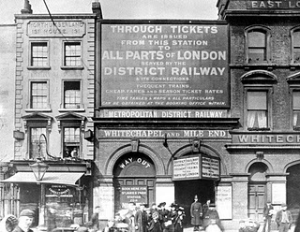 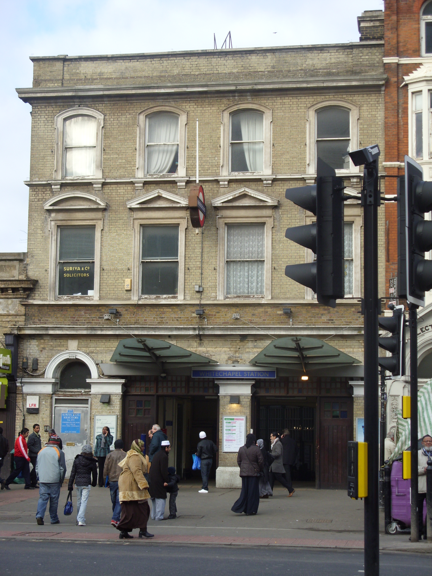
Whitechapel Station in 1876 Whitechapel Station in 2009

As I step out of the Station, I am bombarded with Asian men and women handing me calling cards, mobile phone leaflets to sign up to the cheapest deals, people standing around, others in a conversation, it is a weekday and market traders catching up from their Sunday day offs. The noise level increases as I move out of the station and enter the market, I am showered with market culture, this is the welcoming of Whitechapel: increased noise level, competing market traders, people dodging past, all cramped into a tight narrow road with stalls of fresh fruits and vegetables, clothes and bedding, DVDs, electronics, selling hijabs (Headscarf’s) and jilbabs (long dresses) to serve the community of Muslim women, Halal meat butchers, Fish stalls and then Shops on the right, selling Sari’s, Salwar Kamez’s, some of which hanging at the doorstep of the shops, using the bright, luminous colour to attract the Muslim customers:

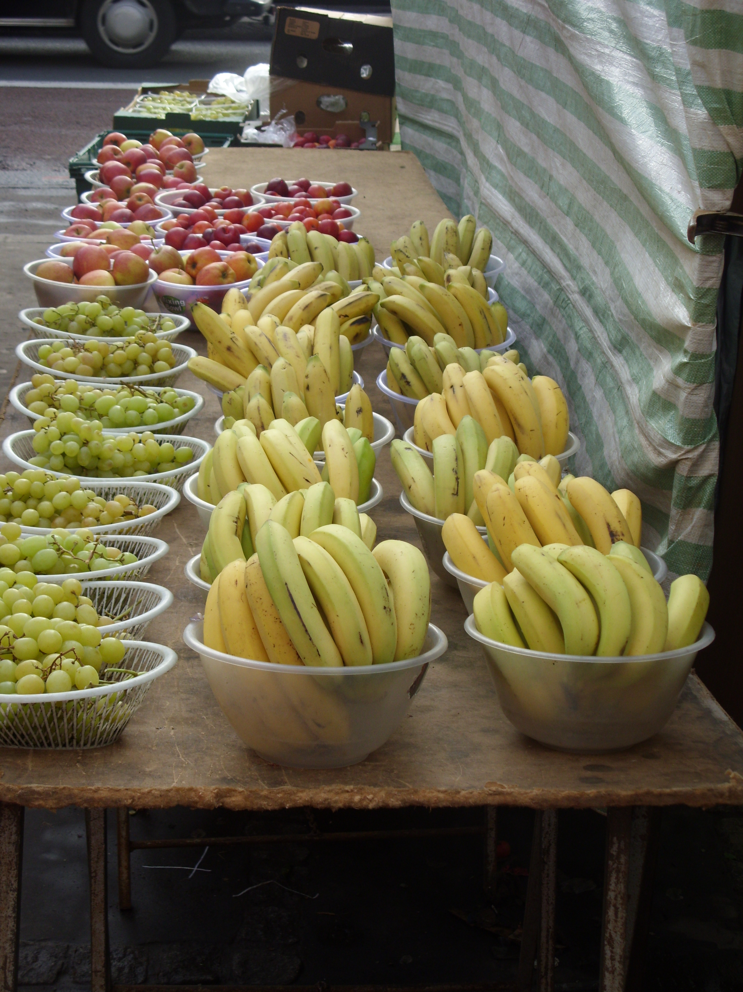
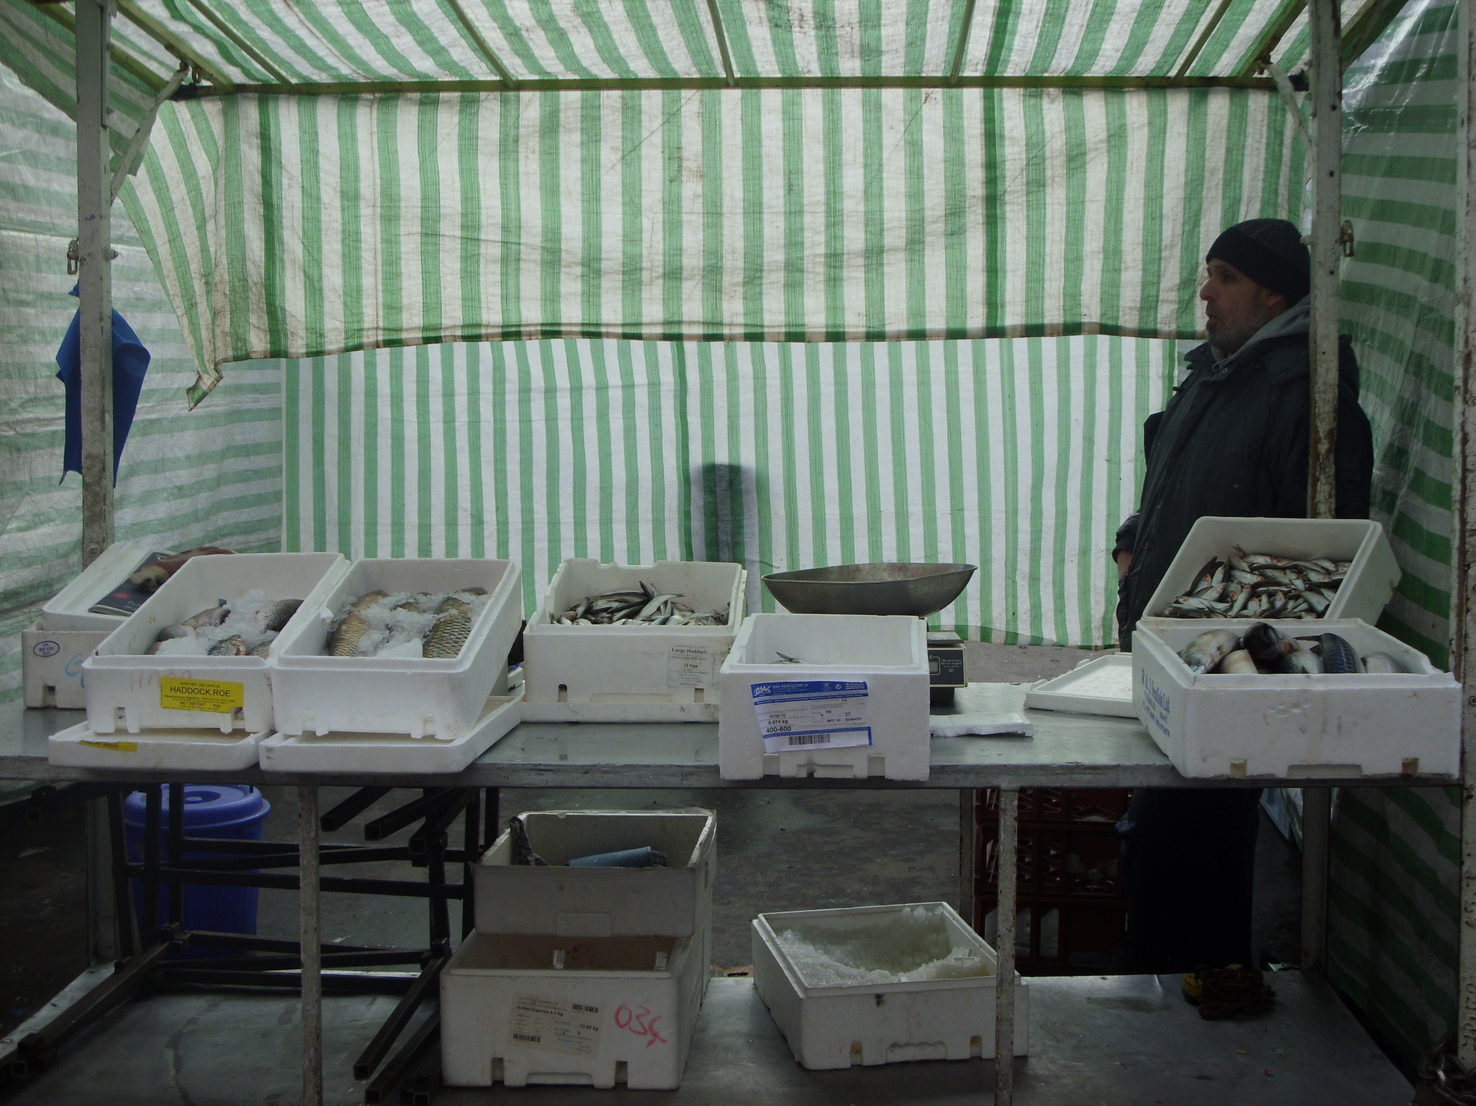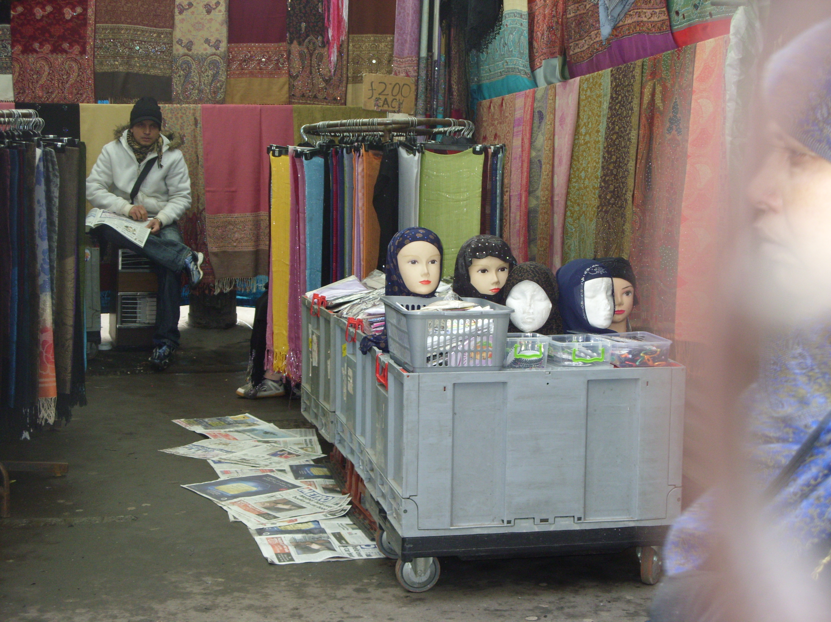

The broad pavements taken over by the stalls, leaving little room for the local people, who struggle to walk along in a straight path. The market holding two hundred years of history, the most integral part of Whitechapel, once home to Jews and the French Huguenots. The Jews utilised the ground floor of their terraced homes for selling food and furniture in the 1930’s, these terraced houses now transformed into sari shops, Perfect Fried Chicken shops and cafes as well as Indian Gold shops. Shops on the right, using racks and hangers for display, spilling into the pavement of Whitechapel road attracting passers by. Small solicitors firm, travel agents and other businesses renting premises above the shops on the right, the area attracting many Muslim communities, from the Somali, Bangladeshi, Pakistani and even Urdu speakers:

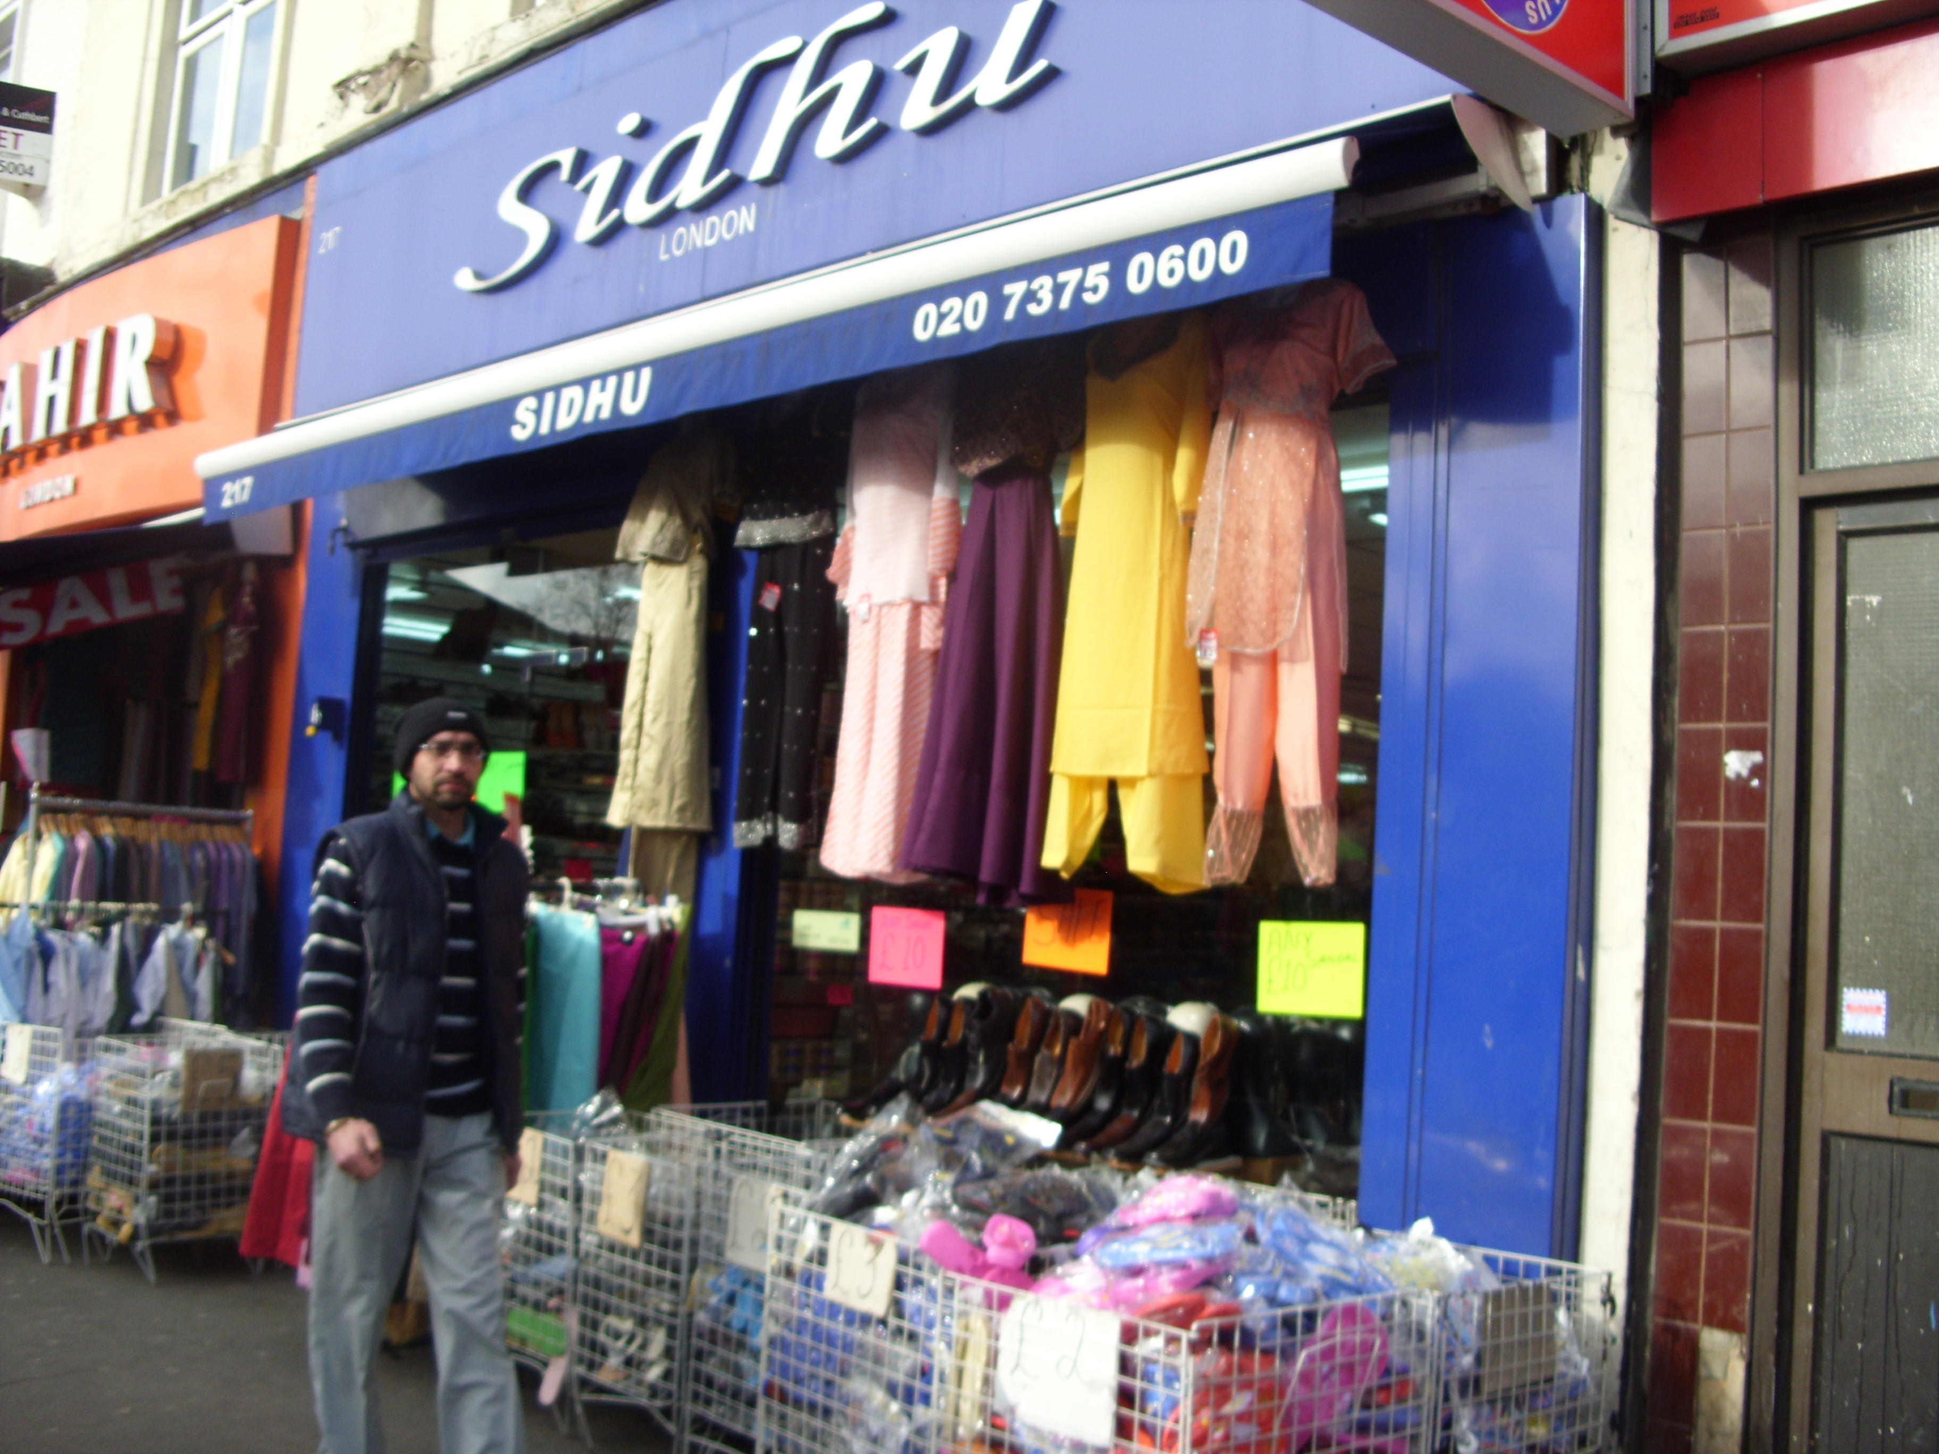

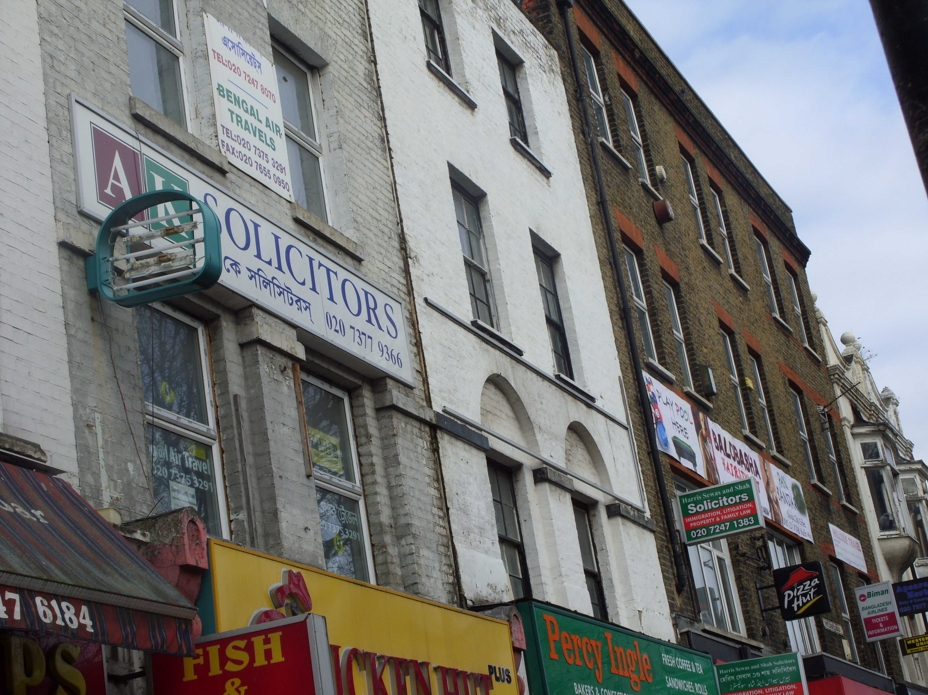

The market is a busy and a lively place, loud music. The station pulls people from as far East as Upminster and West from Ealing Broadway and Richmond. The District line previously known as the Metropolitan District railway, which run from Mansion House, the present name “Whitechapel” station was granted in November 1901, services were limited and trains did not stop at all stations, however now with the Hammersmith and District Line functioning, which calls at almost 60 stations across London. This is likely to increase by the end of 2010 with the reopening of the East London line. This line will attract people from as far South as Croydon, Dalston and Crystal Palace into the thriving, lively Whitechapel Market, once bombed during the Second World War

Damaged physically but despite all the bombing the market continues to exist and bring new businesses, some of the historic buildings remain strong today, such as the Royal London Hospital, the Bell Foundry and even the East London Mosque which was repaired and a majority of the allocated funds from the War Damage commission in 1948. The busy Whitechapel road is one of the busiest daily market streets with high volume of traffic, a place with the second cheapest property location on the British Monopoly game after Old Kent Road. It separates the strong Historic buildings to the thriving Whitechapel market.

I pass many Historic buildings, one of which includes the Royal London Hospital where I was born 24 years ago, but the history of the Hospital stretches as far back to September 1740, previously known as the “London Infirmary”. Many of the Hospital users are the local people, majority of which from the Bangladeshi origin. The brown coloured building and the wide steps are still in place from my childhood. As I stand outside admiring the strength of the building, a loud rattling sound taking over the market and the roads, it is a helicopter landing just above the hospital. There is a clock at the top of the building, five big arched entrances, where many Bangladeshi, White and even Algerian, Polish and other European people standing around, some on Mobile phones, others looking somewhat serious, standing near the Ambulance Vans. The hospital later named “London Hospital” in 1748 till 1990, now known as “The Royal London Hospital” adopted as a 250th anniversary.

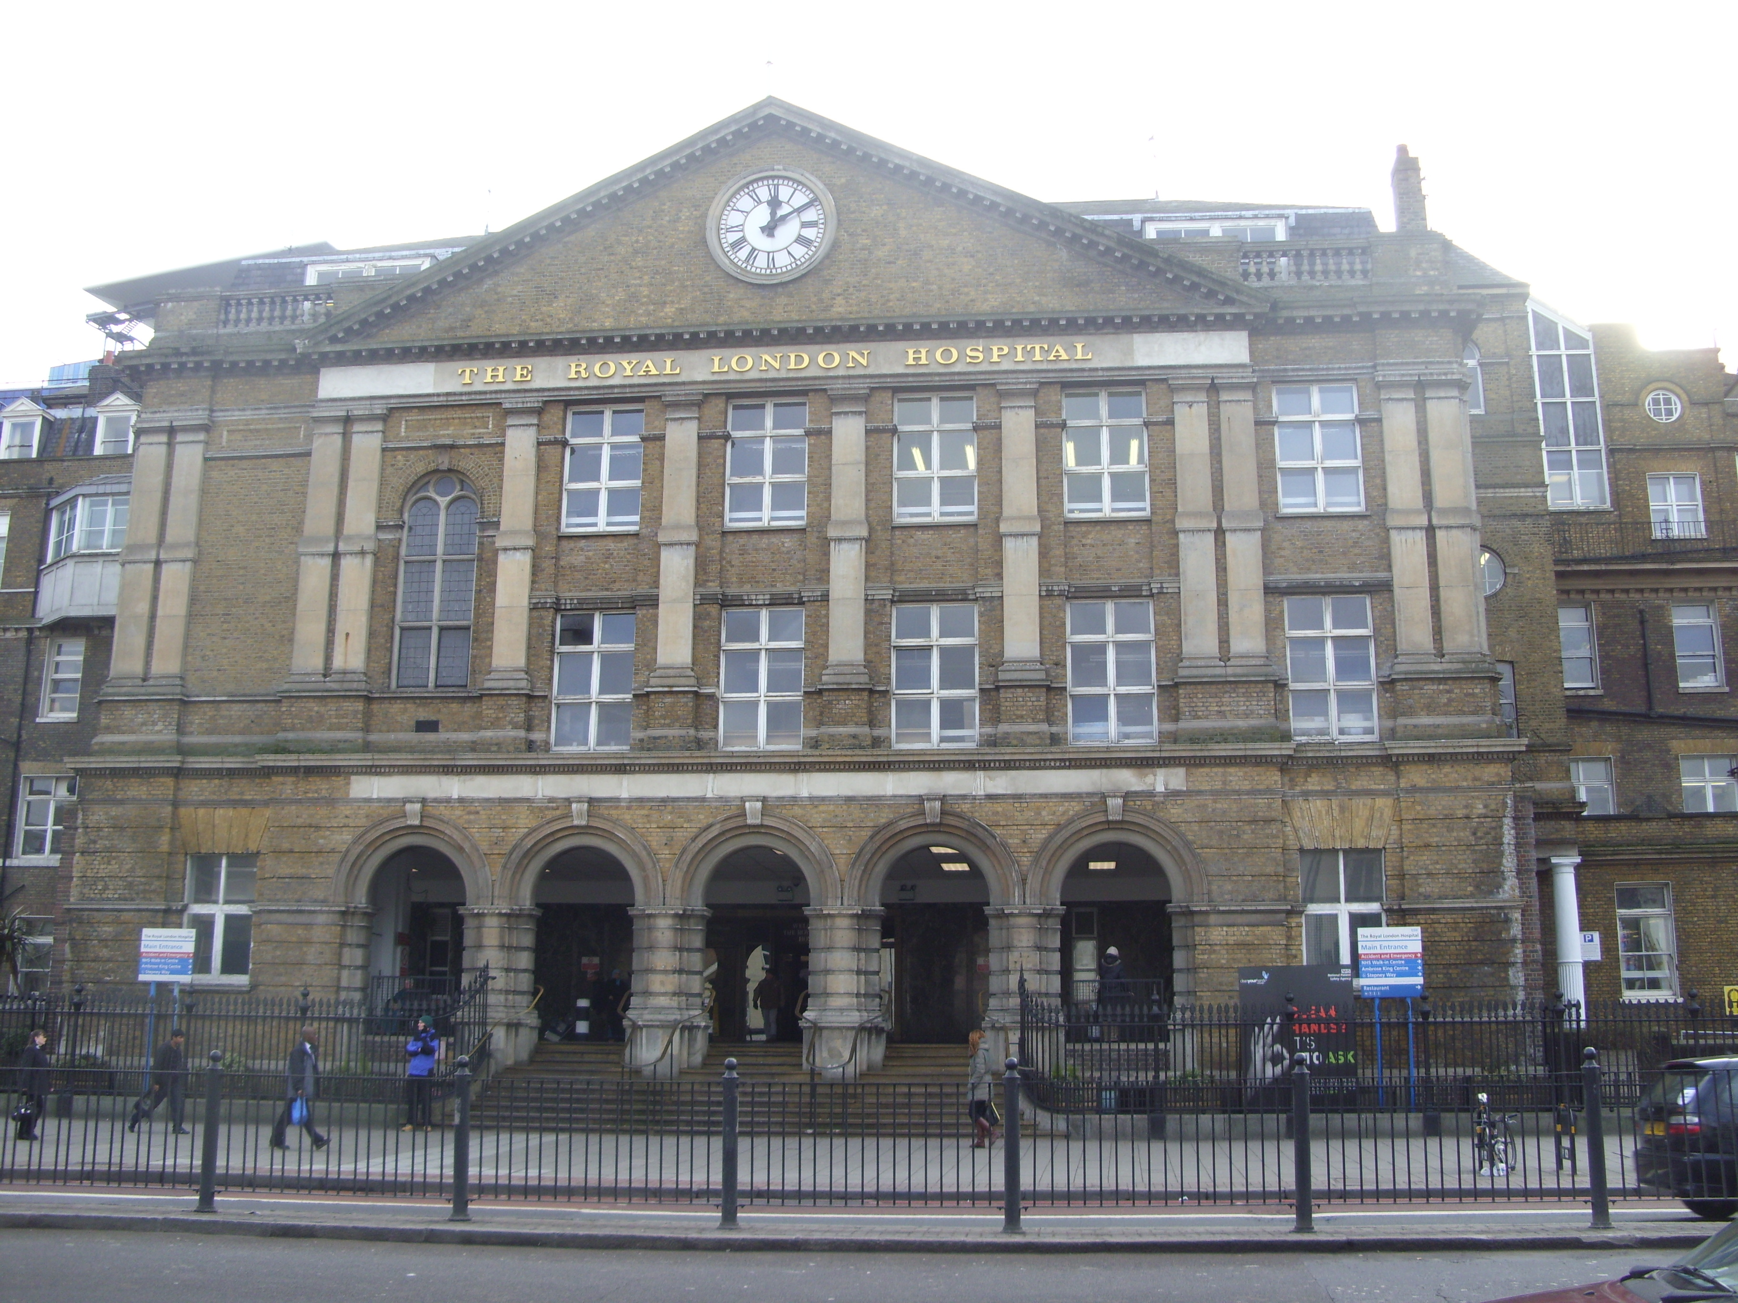

It is part of the Barts and London NHS trust, working closely to serve the local community. The East London Mosque work closely with this service to promote better health for the local people, providing valuable advice on healthy living, raise awareness of heart disease, cancer and many other health problems including Diabetes which is a common illness amongst a wide spread of South Asians. The Hospital once served soldiers during the Second world war and the “Elephant Man”- Joseph Merrick, who spent a great deal of his last few years, currently placed at the medical school nearby to the Hospital, no longer publically exhibited. As a young child, I often walked through the Hospital with my Mum to the Whitechapel Market, parts of the entrance into the Hospital has been blocked up with an amazing, colourful building coming to life. The hospital now houses more services to the Community and this is apparent through the posters placed outside and inside the place, even a “Walk in Centre” is located adjacent to the hospital. The Market sits directly opposite the Hospital, all the people moved over to the Market road, leaving the opposite side almost empty like a nasty plague had entered the road. The hospital once was only standing strong to treat accidents and patients especially during the Second World war but now it has introduced a great deal of more services for the community.

I am facing the “Royal London Hospital” which brings many childhood memories, in order to get to the East London Mosque, I turn right and walk straight down Whitechapel Road. This side of the road is less busy, I enjoy the space around me, as I cross New road, and I find myself walking past a few more Chicken and Chips shop, an Islamic Book shop, a City Citroen Car dealership. I arrive at the East London Mosque. Men from a wide range of origins use the main entrance and the women take the women’s entrance to enter the mosque. Adjacent to the Mosque is the new, contemporary building: The London Muslim Centre which was opened in 2004, where over 15,000 people filled the streets of Whitechapel road, some of which spilling into Fieldgate Street at the back of the Mosque to participate in the Friday Prayers with Shiekh Abdul Rahman Sudais.

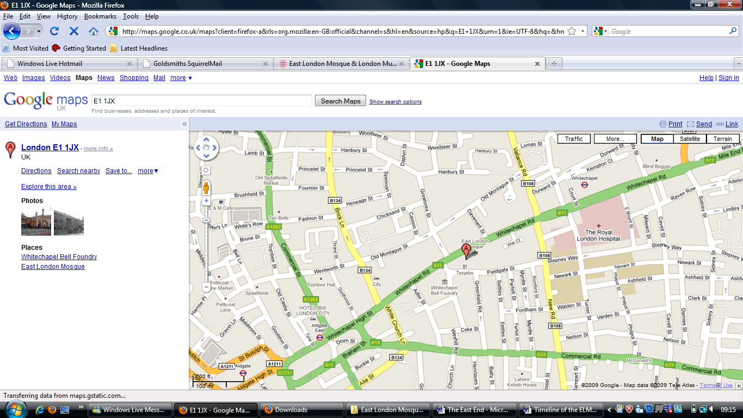
The Royal London Hospital:
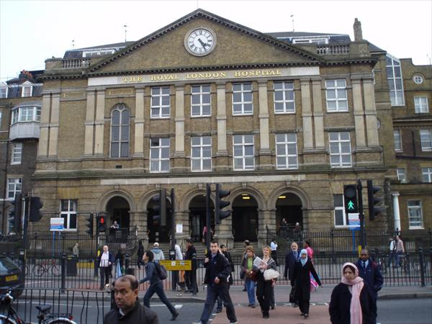
This long line represents the “Whitechapel Market”
The East London Mosque and the London Muslim centre:

“White Chapel” was once surrounding by the vibrant Jewish Community with about 150 synagogues around the area. The immediate area surrounding the new East London Mosque was once dominated by the Jewish community, with the Fieldgate Street Synagogue as the most active Synagogues in the area, established in 1899 and then later rebuilt in the 1950s to accommodate the Local Jewish community. It is currently surrounded by the 5 years old London Muslim Centre on its right, the 25 years of the East London Mosque site on Whitechapel road and the new site to be opened as part of the 100th year anniversary on Fieldgate street to increase services to the Female local community, which seems to be lacking in the current services provided by the LMC and the ELM. The new building is to open in November 2010 as part of the 100 year anniversary of the existence of the London Mosque Fund. The Synagogue looks rather lonely and strange on Fieldgate Street with the LMC and the ELM on either side. I wander if many Jews use the Synagogue. As I walk around the area, I don’t notice any obvious Jews, I am surrounded by Bangladeshi’s, Middle Eastern people and Somali’s.
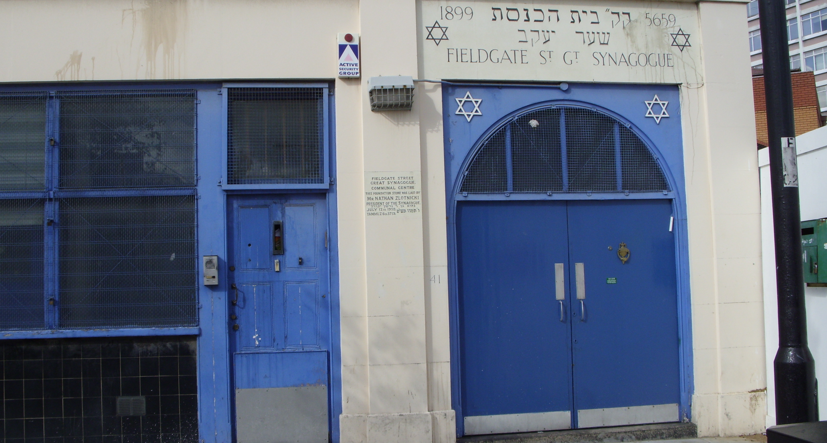

I whisper, “Allaahum-maf-Tahlee Abwaaba Rahmatika” as I enter the Mosque using the women’s entrance. All the women dressed in a headscarf, covered from head to toe, greeting me, “Assalamualikum”, I reply with a “Walaikum salaam”. Taking the narrow stairs up to the First floor, I leave my shoes on the shoe rack. The Mosque holds almost a 100 years of history, survived through the blitz and damaged through the Second World War, the first Eid prayer was held at London’s Hyde Park by British Muslims in 1905, despite poor weather. As I continue to walk up the stairs of the mosque, I enter the women’s gallery, there is a small room on my left, with mosque workers, working incredible hard to serve the community with various issues ranging from women’s health issues, language support, employment advice and help, volunteering opportunities for those who wish to expand their experiences and skills. The sisters working at the mosque always come out in their glowing orange bibs with the East London Mosque logo to keep the crowd in place.

Sitting on the nice, colourful clean carpets are women, some indulging in conversations with each other, others reading the Qur’an, many with their babies, prams and toddlers running around from one end to the other. The mosque provides religious services, advice and even counselling to those in need. Imams are trained at the mosque to deliver valuable advice to meet community challenges, such as drugs, crime, marriage issues, and generational matters along with educational affairs. I walk past the women sitting on the floor chatting and reading to make my way to the ablution room to begin my wudu (ablution of parts of the body to purify myself and prepare for the prayer). I make my way into the main women’s gallery where I and many other sisters decide to perform our short mosque prayer. This is necessary when one enters the mosque, “Tahiyat-Al-Masjid” also known as “Masjadul Salam”, which means greeting of the Mosque, highly recommended for Muslims when entering the place to draw oneself closer to Allah and greet the place of worship.

The building adjacent to the East London Mosque is a lot more contemporary, opened in 2004 and holds many new features, connected to the London Muslim Centre with just a simple narrow path from the women’s area. As I walk through the path I enter the London Muslim Centre and land at a more spacious reception area, with TV screens, floor directories and a massive conference Hall on my left. Wall arts, Islamic calligraphy drawn on rich, bright colours displayed at each floor, cream staircases, wall art hangings almost at every floor, it is a lot more luxurious and modern with innovative technology, such as TV’s. The reception area is big enough to cater for a classroom of 40/50 students, leaving ample space for movement, for funeral coffins to be moved around from the East London Mosque to the London Muslim Centre. The London Muslim Centre provides a wide range of services, which include religious ones, prayer facility during busy periods such as the month of Ramadan, Friday prayers and Eid Prayers. Lectures, training, Tafsir (explanation of the Qur’an) classes delivered in Bengali, Somali and English. Regular Saturday classes aimed at families and a diverse range of speakers brought in to facilitate such lectures to the community of Muslims and also non Muslims who are welcomed at the place of worship on many issues and subjects. As more and more people attend Hajj (pilgrimage to Saudi Arabia during the Dhul Hijjah month of the Islamic Calendar) there are extensive training courses available to them. New Muslims and support is made accessible to the community, where people from all over the city attend, from as far as Harrow, Brent, Wembley and other areas, including local Muslims. Individuals interested in Islam can attend regular classes on Saturdays. Couples wishing to marry can have a marriage certificate handed over under the Islamic Law. Funeral services also take place at the Mosque. Educational classes are vital at the Mosque, evening Madrasa classes for young boys and girls two hours after school Monday to Friday to learn to read in Arabic and Bengali, there are regular Complimentary schools organised by the London Muslim Centre such as Saturday Islamic school, Junior Muslim circle, Food for thought, basic homework and youth clubs to children and young people. A Primary and secondary school for boys, which inspires Boys to become future Imams and Leaders of the Muslim community to make a positive contribution to the British society are held at the London Muslim Centre. It provides broad educational subjects including the national curriculum ones, Islamic sciences and Arabic classes.

As I leave the Mosque I decide to continue to walk down Whitechapel road towards Aldgate East Station, where the Brick Lane Market and the Mosque is located. I walk past the famous Bell Foundry, which looks like an old pub, listed in the Guinness world book of records as Britain’s oldest manufacturing company, established in 1570 during the time of Queen Elizabeth I. Famous sites such as the Big Ben in Westminster have had bells designed here, I feel privileged to be walking past the building, keen to enter the place and look inside, but it looks like a very old building and no one inside, but I do not stand around for too long looking right into the place. I continue to walk down the road, past Altab Ali Park, which was in memory of Altab Ali who died after being attacked by three white youths as a racist attack. Murdered in 1978 at the age of 27, parts of the park were also damaged during the Second World War. An arch made by David Peterson is partly modern and partly old, designed in a Bengali style for the merging of the two cultures around the area.

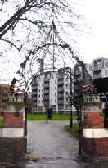

I finally arrive at Brick Lane (also known as Bangla town), with many curry houses, Gates made colourful using the Bangladesh flag colours of Red and Green. If I had walked through Bangla town at the earlier part of the century I would’ve past many Jewish women selling beigels. I continue to walk down to find myself at Brick Lane mosque which tells the story of the East End. This was built in 1753 by the French Huguenots, who used the space as a French Protestant church located on a French street name: Fournier Street. Later transformed into a Jews Chapel in 1809, a Methodist Church in 1819 and a Synagogue in 1897, known as the Spitalfields great Synagogue to serve the influx of Yiddish Speaking Jews in the East End of London. In 1976 the East End underwent a severe make over, the Great Spitafields synagogue renovated its name and with some changes to the building became known as the London Jamme Masjid, where just over 4000 worshippers can be accommodated in the prayer halls. The congregation often spilling out into the roads of Brick Lane during special occasions (Eid Prayers, Ramadan and Friday prayers). Serving the needs of the Bengali community living in the area with a school located on the first floor of the old, ragged building. This one space symbolises change and continuity of the East End with over thousands of years of solid history told within the roads, road signs, buildings and even houses, markets which continue to function but with some make over and colour to suit the needs of the new communities. It tells the story of the East End.



